FUNCTION SEARCH AND REPORTS

In Tryton, reports serve the purpose of presenting data in a structured and user-friendly format. They allow you to extract, organize, and analyze information from various modules within your Tryton system. Here's a breakdown of the key aspects:

we’re are going to do this steps by steps and explain the reason of each action making understanding why are important and necessary.

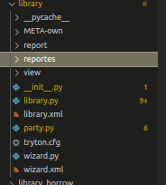
This is a simple report based in the data stored in the database take them in out on some document the most common is (odt) odt is a type of file like pdf the only difference is that (odt) allow you to connect with more dynamic in the data transfer. Basically python transform this in past to the document. How we can fo that.

In library folder create another folder inside called (reportes) in this folder we will insert the content necessary to display the file with all the report this is just to keep a order and make simple to understand.
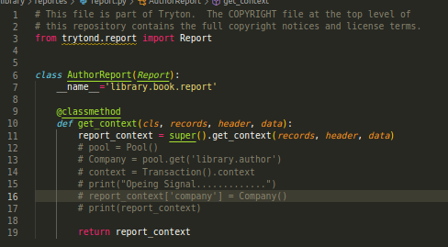

Inside of that folder we added a new file called (report.py) adding the code above. This is the first step to start the report.

In the (get_context) we get access to all the record where we are doing the report, more forward we gonna see how can be this possible of how in can be linked.

CREATING XML CONNECTION FILE

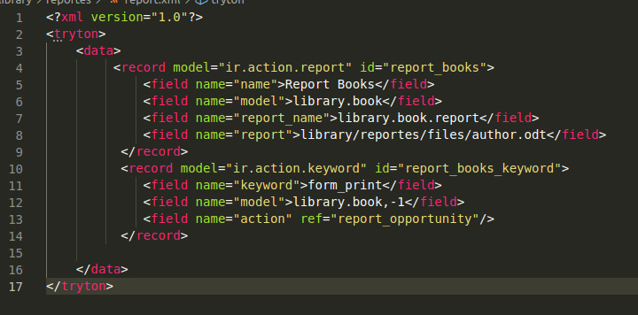

name: The report name, basically the name that you wnat for that report.

model: Name of the module, in this case (book.library)

report_name: Basically the name of the report, name the
the we set up in the class (__name__='library.book.report')
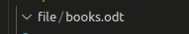
report: The file extension of the document where display the data.
We need to create an odt document (We talk about it later).

ir.action.keyword

from_print: The mosh common used just to tell to triton that this gonna be for form_print.

model: Name of the module, and the possition (-1) meand the position

Action; TAKE THE ID OF ACTION REPORT

After that we need to add the new report in the __int__.py. And add news dependencies with the xml report we can move the report.xml outside it will not change anything, it will make more simple adding to the dependencies.

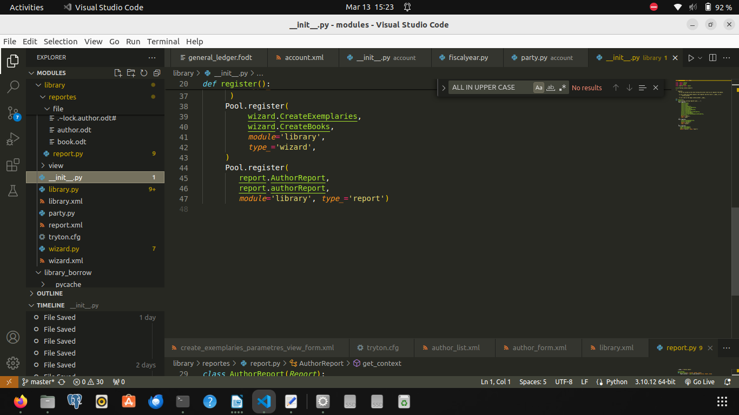

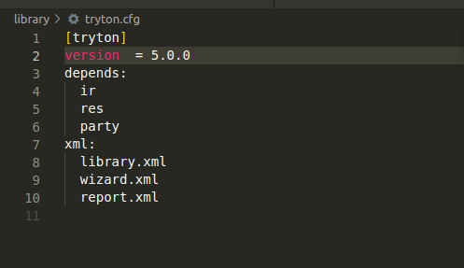

After all this configuration has been completed.

The .odft:
These documents are typically created using programs such as Apache OpenOffice Writer and LibreOffice Writer, word processing programs comparable to Microsoft Word and Google Docs. ODT files are similar to file formats created using Word, such as DOCX and DOC. this basically allow you to expand the document and event create placeholder, you should be say that this is a especial version of the extent ion like (Docs and DOC) mentioned before. modifing and connecting with the code make it dynamically i will show u that.

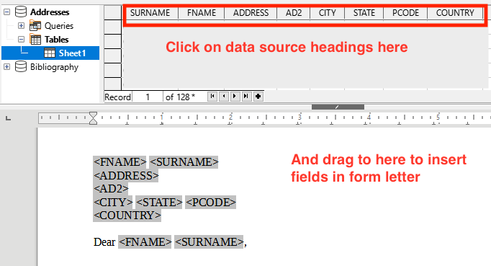
This information can be contained by the report_context:
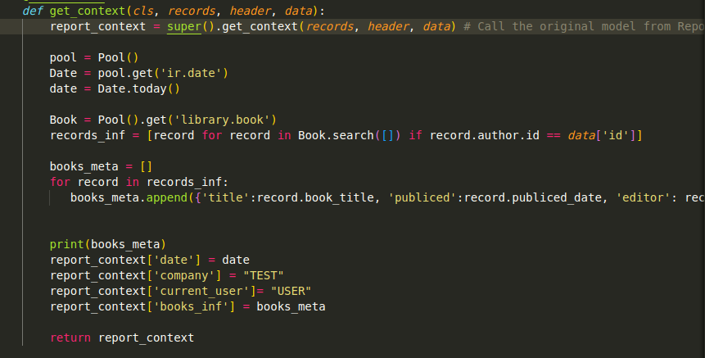

It can be parsed by the odt document
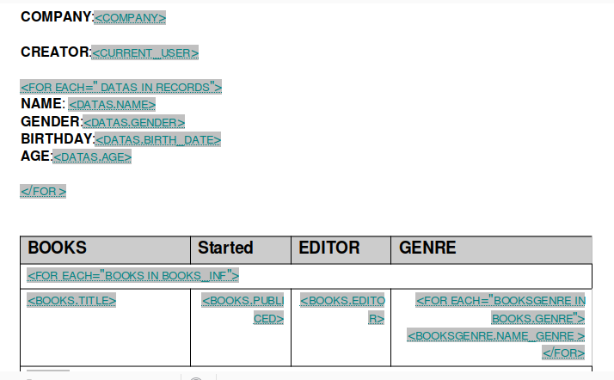

It will parse the Carla Information

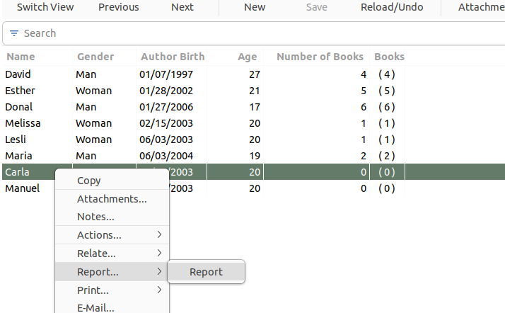

It will show in the document.
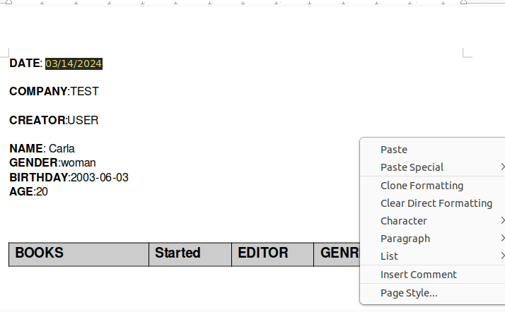
It can be possible create more advanced form depending how good yur’e
using odt.

